For Immediate Release
Contact: Tammy Wilson, CEO
(951) 677-5599 ext. 2259
www.oakgrovecenter.org
tammyw@oakgrovecenter.org DRAFT

Oak Grove Center Hosts Annual So-Cal Chef Open Media Event

June 8, 2021, Murrieta, California – Oak Grove Center will host the Oak Grove So-Cal Chef Open Media Event on Friday, June 25th. Chefs Rosie O’Connor and Steven Moore, aka Trendy Chef, along with Wahoo’s Fish Taco owner, Wing Lam will be this year’s featured celebrity chefs. Chef Rosie will be this year’s Lead Judge. She is the Executive Chef and Owner of Provecho Grill and appeared on Food Network’s Supermarket Stakeout, as well as the Cooking Channel’s Farmer’s Market. She’s currently the only past winner to earn both the People’s Choice & Pinnacle Winner awards. Steven Moore, aka Trendy Chef, is a past winner of Food Network’s Supermarket Stakeout with guest judge Bobby Flay. Restauranteur, speaker, philanthropist and surfer, Wing Lam, who serves as CEO of Wahoo’s Fish Taco and co-founded the global franchise brand in 1988 with his brothers, will round out this impressive team. 2020 Pinnacle Award winner, Chef Justin Mabunay, from local favorite, Urbn Market Fusion will also join the three celebrity chefs.

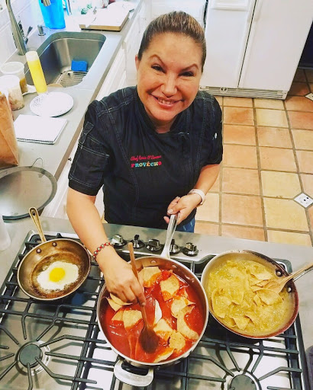

Rosie O’Connor
Steven Moore
Wing Lam

The media event will provide Food Writers, Bloggers and Influencers a chance to meet the competing chefs, taste Temecula cuisine and meet the celebrity judges. A highlight of the evening will be Trendy Chef’s live cooking demonstration. Reservations for the Media Event are required (Insert link to RSVP page and form).

Proceeds from the So-Cal Chef Open benefit Oak Grove Center’s culinary vocation program, Culinary Creations. The 14th Annual So Cal Chef Open and 19th Annual Oak Grove Golf Classic will be held on August 30th, 2021, at the Temecula Creek Inn and Golf resort. Tickets are on-sale now at www.oakgrovecenter.org/events/chefopen/. To make a donation, visit www.oakgrovecenter.org

Oak Grove Center is a nonprofit residential, educational and treatment Center (with multiple campuses) for children throughout California with psychological, emotional and behavioral problems and special needs. Oak Grove Center’s mission is to rebuild the lives of at-risk children and their families through educating, healing, restoring relationships, building character and instilling hope.
####

