Executive Summary School Accountability Report Card 2017-18
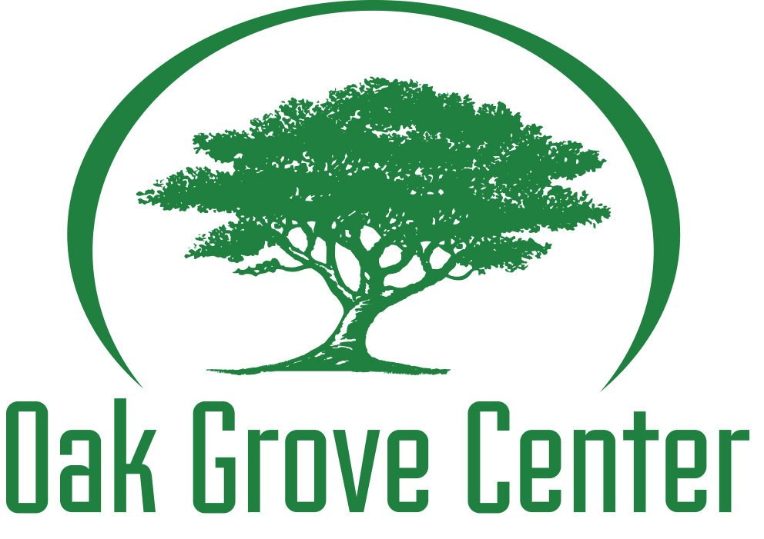
Jack Weaver School
The executive summary of the School Accountability Report Card (SARC) is intended to provide parents and community members with a quick snapshot of information related to individual schools. The most current data available was utilized as appropriate in the development of this report. For information about the school, parents and community members should review the entire SARC or contact the school principal.
Contact Information
Oak Grove Center / Jack Weaver School
Local Education Agency – Murrieta Valley Unified School District
24275 Jefferson Ave, Murrieta, CA, 92562
(951) 677-5599 (phone) / (951) 677-4549 (fax)
Director of Education (Principal) - Athene Banche, M.Ed.
atheneb@oakgrovecenter.org
CDS Code – 3375200-7071533

About This School
Oak Grove Center has developed a mission statement that is reflective of the beliefs and values that the organization has deemed most appropriate for the type of programming available through Oak Grove Center. The mission of Oak Grove Center is to rebuild the lives of at-risk children and their families through educating, healing, restoring relationships, building character and instilling hope. With a tagline of “empowering success * transforming lives”. Oak Grove Center’s mission drives the focus of the program and is the basis for services made available to our students and their families. Oak Grove Center offers a strength-based, individualized learning experience for our students to meet their unique needs. Teachers are dynamic, creative, and understand the unique needs of our population and implement the most relevant methods to help our students achieve educational success.

Expected Schoolwide Learning Results

Oak Grove Center has developed the following expected schoolwide learning results:

The Mighty Oaks REACH for the sky.

Resilience: Students overcome obstacles and adversity through use of problem solving skills / techniques
Excellence: Students attend school daily and on time
Academics: Students pass classes enrolled in earning credits towards diploma and / or certificate of completion
Character: Students are respectful, caring, involved citizens who contribute to their communities in a positive manner through volunteerism / service learning
Honor: Students are effective communicators who address their wants / needs through positive self-advocacy

Curriculum and Instruction
Oak Grove Center (Jack Weaver School and Oak Grove Center at the Ranch) is certified to serve students in grades K-12, ages 5-22. All students enrolled at Oak Grove Center (Jack Weaver School and Oak Grove Center at the Ranch) attend school for a minimum of 314 minutes per day. For Kindergarten students, instructional minutes will be decreased to meet education code requirements (240 instructional minutes per day).
Classrooms have the maximum number of students allowed by master contract, 1 certified / permitted teacher, and a teaching assistant. At Jack Weaver School, high school students participate in a block schedule while middle and elementary aged students participate in a period schedule. High school students may complete credit recovery on an individual basis, based on home school requirements, for a maximum of 35 credits in class and 10 credits on an independent study basis per semester. Students may participate in Acellus, online learning program, for independent study courses or when needing to work more independently from the group.
All academics/programs (including the Acellus program) are based on the California Common Core State Standards. All classrooms have Common Core Standards Binders that include the California Common Core State Standards in ELA / Math as well as helpful resources and tips for implementing standards. Those classes that provide functional skills curriculum also have access to CCSS, Prioritized ELA CCCs, and Essential Understandings in Reading, Writing and Math. Focus is on increasing depths of knowledge, project based learning, higher level thinking and collaboration. Although not yet certified in this area, Oak Grove Center follows district A-G requirements. General education textbooks are adopted equal to those of the Murrieta USD (JWS) and Val Verde USD (OGR) for high school students, or State approved for elementary / middle school students. Adapted texts, educational computer software and supplemental materials used are also consistent with those that are adopted and approved by the state of California. All textbooks meet the state requirements with regard to standards / essential standards, and teachers work to ensure that standards / essential standards are addressed when developing IEP goals and objectives and lesson plans.
Career education is offered through the COIN software program, Learn to Earn materials, Kuder Career training program, and other workbooks / materials. Inclusion at local schools, structured work experiences, WorkAbility and attendance at the local Jr. College or ROP vocational classes are offered when deemed appropriate by the treatment team and the IEP team. High school students may also study and be taken to sites that offer the GED or CHSPE, or opt for a Certificate of Completion if approved by the IEP team.
Courses range from college prep to alternative functional curriculum such as independent living skills, communication, survival math, community awareness and prevocational / vocational experiences. Students enrolled in the alternative functional curriculum (those taking the California Alternative Assessment) receive curriculum through The Curriculum Guide for Students with Moderate to Severe Disabilities – Core Content Access published by the CA County Superintendents Educational Services Association in conjunction with Lakeshore Publishing (SEACO).
Oak Grove Center Center (JWS) has 3 specialized classes that serves students with autism or more moderate / severe needs. Curriculum for these classrooms is individualized for each student based on their levels of functioning and can include standards based core curriculum, alternative functional curriculum, vocational activities / training (WorkAbility), and life skills activities.
Teachers employ various instructional methods based on student need, learning style (determined by a learning styles inventory created by Dr. Ray Barsch, a CSUN professor of learning disabilities), cognitive level, and the nature of the lesson. Individual instruction, collaborative groups, independent study, direct instruction, and evidence based methods are utilized. Students have access to general education textbooks, adapted textbooks (as appropriate), modified textbooks (as appropriate), workbooks, individually designed work packets, educational software and internet access in order to complete assignments.
Designated instructional services (DIS) provided are Occupational Therapy (OT) for sensory integration, fine and gross motor skill development and Language and Speech (LAS) pragmatics, language and articulation, individual, group, or consultation based on IEP recommendations. Counseling and therapy are part of the basic programming as noted below.
Day students receive the following level of therapeutic service (unless IEP team agrees to different services):
Individual Counseling 60 minutes per week
Day students in the Autism Program (M/S) receive the following level of therapeutic service (unless the IEP team agrees to different services):
Case Management and Planning 60 minutes per week
Residential students receive the following level of therapeutic service (unless IEP team agrees to different services):
Individual Counseling 60 minutes per week
Group Counseling 50 minutes 2x per week
Parent Counseling and Training (Family Therapy) 60 minutes 2x per month

Behavior Management Program
Oak Grove Center (Jack Weaver School and Oak Grove Center at the Ranch) has the capacity and trained staff to develop individualized behavior support plans (BSP) for students, conduct functional analysis assessments (FAA), and develop positive behavior intervention plans (PBIP). Oak Grove Center utilizes a multi-tiered approach to behavior intervention and focuses on what changes need to occur related to instruction, curriculum, environment and learner to address behavioral difficulties. Oak Grove Center will work with the individual district to determine need for such plans and will work with the district in the development of the plans as deemed appropriate and agreed to by the IEP team. Once developed, all PBIPs are part of the student’s active IEP. All behavior plans follow the format designated in the Education Code as “Positive Behavior Intervention”, including recommendation, assessment, development, implementation, review, and revision. The intent of the plan is to provide positive intervention strategies designed to shape appropriate behavior as a replacement for assessed or observed maladaptive behaviors. The function of the behavior is also identified and replacement behaviors as well as positive reinforcers are implemented to help reshape behavior. The school will never employ any behavioral procedure deemed negative, aversive, or punishing, instead utilizing procedures which are considered positive and non-aversive.

Oak Grove Center also follows a discipline policy with students receiving varying levels of discipline for school and classroom rule violations. Suspension is utilized as appropriate when the behaviors are so extreme as to be disruptive to the school program and / or dangerous to other students or staff members as defined by Education Code, EC48900.

All school staff receives training in Positive Behavior Intervention, including rationale, student need, procedures for intervention as designated by the Education Code, and protocols for assessment, development, implementation, monitoring, and documentation. Only trained staff members are permitted to participate in the implementation of a behavior plan.

Oak Grove Center follows Education Code in relation to creation and implementation of PBIPs, working closely with our districts of service. PBIPs are only modifiable by the IEP process. The Treatment Team may make recommendations but may not unilaterally amend the plan.

Behavior Emergency Reports (NPS) / Special Incident Reports (Residential) are completed when required for any form of restraint (escort, seated, wall, prone), AWOL, Police Involvement, Injury, or any other serious incident. Reports contain information related to the student(s) involved, incident details, staff members involved, interventions utilized, student response to the interventions, details of restraint, parties notified (parents, district personnel) and any other relevant information. Reports are forwarded to appropriate district personnel as required. IEPs are scheduled to discuss events as requested / necessary.

All staff members are Pro-Act trained to deal with challenging situations that can result in injury or harm if more restrictive interventions are not utilized. Some staff members are also trained in Crisis Prevention Intervention (CPI). Typically staff members working with our Autism population or our elementary students are dual trained (Pro-Act and CPI) in order to work more effectively with these populations.

Opportunities for Parental Involvement
Oak Grove Center / JWS is an open campus for parents, allowing them to become an active part of their student’s educational program. Parents are encouraged to schedule classroom visitations, volunteer for school events, and meet with staff members. Oak Grove Center provides ongoing communication to parents through daily point sheets, monthly treatment team reports, quarterly progress reports / report cards, and regular announcements of upcoming or special events. The school maintains an annual calendar of activities / events, many of which allow parents the opportunity to participate including; specialized outings, sports events, poetry slams, specialty groups, assemblies, cultural diversity week, Multicultural History Month (Feb), Safety Awareness Month (Mar), Autism Awareness Month (Apr), Red Ribbon Week (Oct), open houses, and promotion / graduation ceremonies.
Parents are active members in the IEP process as well as active participants in the treatment team process.
Oak Grove Center also offers ongoing parenting courses open to all parents.
Parents interested in volunteering may contact their child’s teacher directly to request volunteer opportunities. All requests will be reviewed by the Director of Education in conjunction with the school’s management team prior to approval.
Student Enrollment
JWS currently serves students from 44 districts throughout California as well as a small amount of students who are privately placed in the program via insurance or other means. JWS has the capacity to serve students from K-12th grade. Current enrollment (January 2018) includes the following grade levels: K (0%), 1st (0%), 2nd (0%), 3rd (6%), 4th (2%), 5th (8%), 6th (5%), 7th (5%), 8th (8%), 9th (14%), 10th (16%), 11th (15%), & 12th (21%)
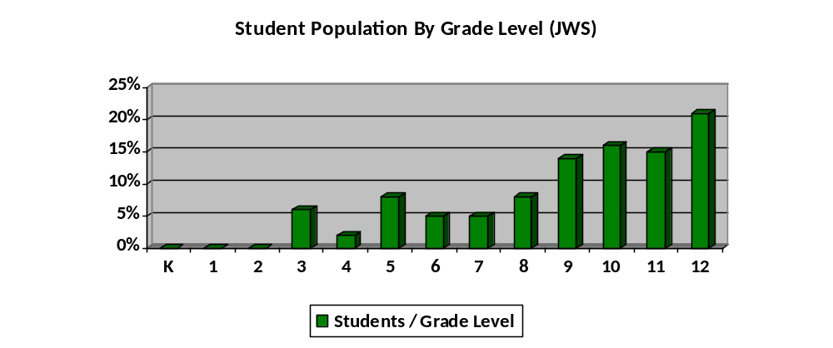
The unifying factor in consideration of placement is the student’s background of chronic and pervasive mental health and behavioral issues, as well as the inability to be successful academically in a public school environment. This is a case in which the makeup of the student body does not truly emulate that of the local community.

JWS has a diverse student population and has tracked the ethnic makeup of the population for the past three years, taking representative samples at 6-month intervals from January 2015 through January 2018. Collection of intermittent data provides a good longitudinal look at placement and population trends due to the transient nature of the school’s population.

The ethnic breakdown of the student population for the past three years is as follows:

Ethnic Makeup of the Student Population (JWS)
 | Caucasian | Hispanic | African American | Native American | Asian | Filipino | Korean | Other | 2 or more
01/15 | 55% | 23% | 19% | 2% | 0% | 0.5% | 0% | 0.5% | 0%
07/15 | 47% | 25% | 23% | 1% | 1% | 1% | 0% | 2% | 0%
01/16 | 43% | 21% | 21% | 1% | 4% | 0% | 0% | 1% | 9%
07/16 | 44% | 25% | 17% | 0.5% | 2% | 0.5% | 0% | 2% | 9%
01/17 | 41% | 29% | 17% | 0% | 0% | 2% | 0% | 2% | 9%
07/17 | 38% | 29% | 18% | 1% | 1% | 0% | 0% | 7% | 6%
01/18 | 40% | 30% | 17% | 1% | 3% | 0% | 0% | 3% | 6%

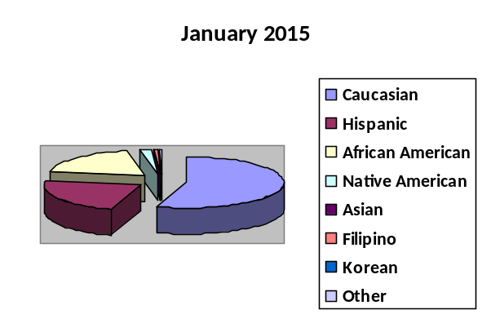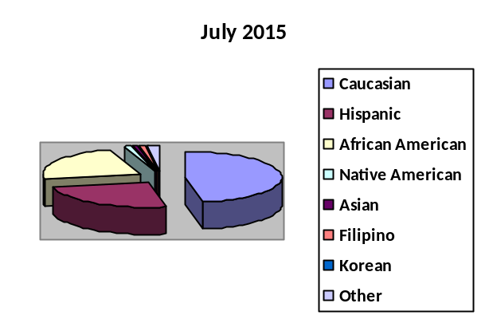

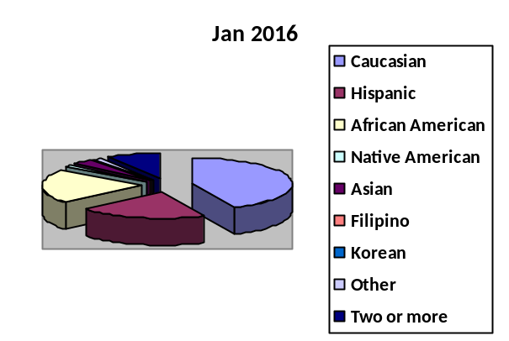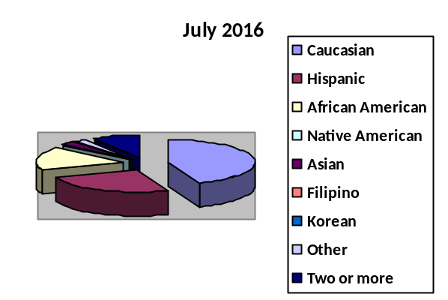

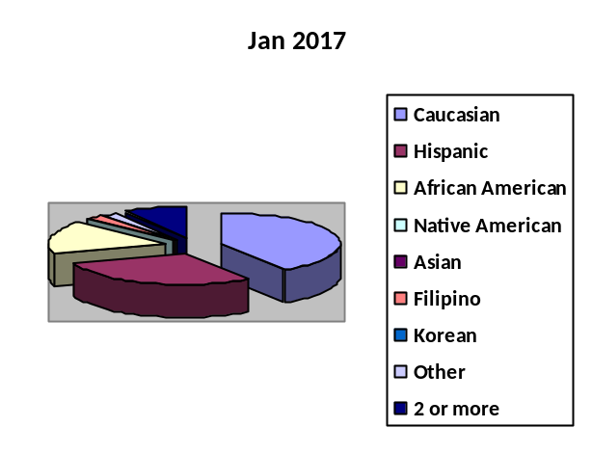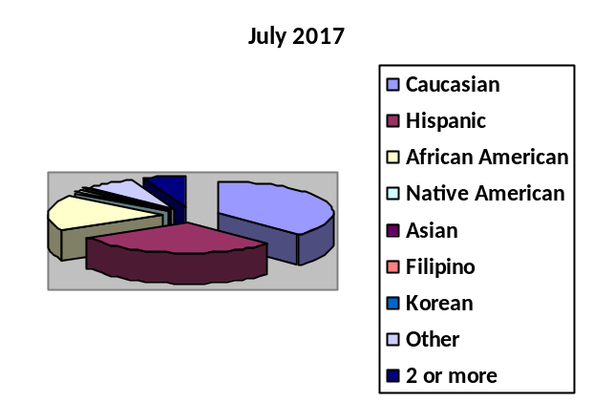

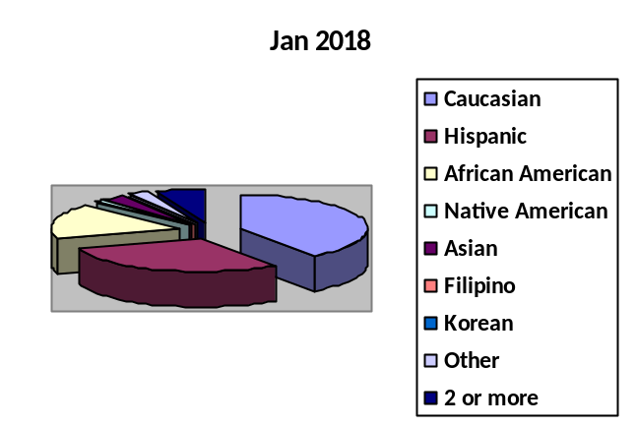

Due to the diverse student population on both campuses, lessons, classroom activities & school wide activities reflect an ongoing emphasis on cultural awareness. Staff members are also required to participate in annual training that addresses issues related to cultural diversity and sensitivity. Focus continues to be placed on ensuring that students are demonstrating appropriate interactions with peers, staff and community members that are accepting of all ethnicities.

Both JWS and OGR are also sensitive to our unique population of learners and celebrate differences. Both JWS and OGR have participated in different activities geared towards acceptance of differences including Cultural Diversity Month (February), Safety Awareness Month (March), Autism Awareness Month (April) and Red Ribbon Week (October).

JWS is a coed facility. JWS has historically had more male students than female students. In terms of the schools’ gender mix, data from the past 3 years indicate the following:

 | Jan 2015 | July 2015 | Jan 2016 | July 2016 | Jan 2017 | July 2017 | Jan 2018 | Jan 2015 | July 2015 | Jan 2016 | July 2016 | Jan 2017
Male (JWS) | 67% | 64% | 63% | 66% | 71% | 68% | 69% | 67% | 64% | 63% | 66% | 71%
Female (JWS) | 33% | 36% | 37% | 34% | 29% | 32% | 31% | 33% | 36% | 37% | 34% | 29%

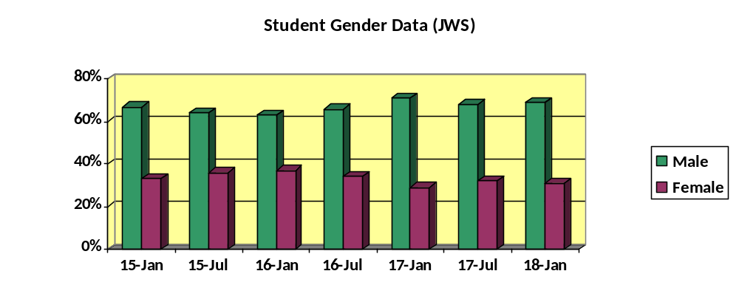

English Proficiency
Almost all students attending JWS are identified as English Only on home language surveys / IEPs. If a student with limited English proficiency were to be admitted; all teachers have English Language Authorization as part of their credentials to work with students classified with English as a second language. Oak Grove Center would provide English Only instruction with use of SDAIE strategies / classroom accommodations and modifications as necessary to support these students. JWS has the capacity to provide translators for IEP and other meetings for parents who require this service.

Special Populations
The majority of students attending JWS have an active IEP indicating their qualification for special education, as well as annual goals, objectives, services required, and other related data. In some cases, students are referred from non-educational sources or through private insurance and may not have an active IEP. The school is certified by the State of California and authorized to provide services for students with the following disabilities: Autism, Deaf Blindness, Emotional Disturbance, Intellectual Disability (Mild/Moderate & Moderate/Severe), Multiple Disabilities, Other Health Impairment, and Specific Learning Disability.
JWS currently (January 2018) provides services to students with the following primary disabilities: Emotional Disturbance (43%), Autism (27%), Other Health Impairment (13%), Intellectual Disability (2%), No Disability (10%), Specific Learning Disability (4%), and Traumatic Brain Injury (1%).
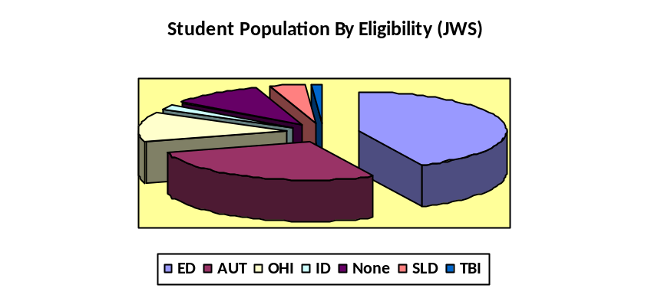
JWS is also authorized to provide the following related services: Behavior Intervention Design and Planning, Behavior Intervention Implementation, Counseling and Guidance, Health and Nursing Services, In Home and Hospital Instruction, Language and Speech Development and Remediation, Non-medical Care Room and Board, Occupational Therapy, Parent Counseling and Training, Psychological Services, Recreational Services, Social Worker Services, and Vocational Education Career Development.

School Safety Plan
The school has a comprehensive safety plan in place. Our Director of Environmental Services has developed a system for on-going monitoring of the physical plant. Oak Grove Center also conducts monthly / annual safety drills to ensure that students and staff members understand how to respond during various disasters including fire drills (monthly), campus “lock down” drills, earthquake drills, and other safety awareness drills as appropriate as identified by the management team. An inventory of safely supplies is maintained and updated regularly to ensure that materials are available for use in the case of a true disaster. All staff members participate in an annual fire / disaster safety in-service, and all must be certified in CPR, First Aid and AED. Those staff members that monitor students in the pool are trained in Water Safety. All students are trained related to Transportation Safety. Additionally, all staff members are trained in Pro-Act or CPI to assist appropriately during behavioral emergencies.
School Facilities
Oak Grove Center’s campus is highly conducive to providing academic instruction as well as therapeutic intervention. The campus is beautifully maintained, with 14 classrooms (12 currently in operation) on an open and airy 12-acre site. Ten classrooms, 5 therapist offices, the transportation center, the Education Department and Day Program, WorkAbility, computer lab, read 180 lab and testing offices are located in the main classroom building. Across campus, one classroom (elementary) is located in a residential dormitory, with four other classes, four therapist offices and two conference rooms located in our second set of school buildings on the opposite side of campus. The school additionally has one main IEP / conference room and a multipurpose media center / library used for treatment team meetings, IEP’s, staff training, and student functions. The school has a baseball field, swimming pool, and a state of the art gymnasium that contains a weight room, sensory / play room, game room, multi-purpose rooms for arts / music and extra office and storage space.
All staff receives thorough training in policies related to health, safety and wellness. They are introduced to the concepts during the new employee orientation, and then attend in-services scheduled throughout the year. The fire safety in-service is mandatory for all staff on an annual basis. Additionally, all staff is ProAct trained every two years, as well as receiving training in CPR, first aid, water safety (we have a pool), infection control, and emergency response. Further, staff is trained in positive behavior intervention, and a dual training (Staff Effectiveness Training and Effective Treatment Interventions) that provides positive, non-aversive alternatives to the use of physical intervention. We also conduct regular drills for fire, natural disasters, and terrorist threats. Following each drill the management team conducts a debriefing session to review the compliance and effectiveness factors, as well as and problems that need to be addressed.
The most recent site inspection by the fire department indicated no deficiencies. Oak Grove Center maintains the facility quite well and employs full time maintenance staff members who handle any ongoing maintenance needs.
Oak Grove Center has completed the renovation of our parking area. Our entrance to the facility is on Lemon Ave. The Jefferson Ave. entrance/exit is gated and locked, it is no longer in operation except for emergency vehicles. Please be sure to enter the facility on Lemon Ave.
Oak Grove Center has implemented a School Wellness Policy that ensures students are provided healthy nutritional meals and snacks and that promotes a healthy and active lifestyle. Oak Grove Center supports and reinforces wellness through health education, physical education, health services, nutrition services, psychological and counseling services, a safe, healthy, connected school environment, and parent/guardian and community involvement.

Education Department Staff Data (January 2018)
JWS employs one Director of Education, one Program Specialist, one Assessment Administrator, one Educational Support personnel, one Administrative Assistant II, and thirteen full-time teachers. All teachers are appropriately credentialed with a large majority holding Master’s Degrees in Education. Oak Grove Center does not hire teachers below the PIP/STSP level due to State regulations and guidelines. The Director of Education holds a Master’s Degree in Education with an emphasis in Special Education as well as a Clear Level 2 Education Specialist Credential and oversees all school operations. The Program Specialist serves as the Testing Coordinator and oversees the majority of IEPs. The WorkAbility Coordinator / Education Dept. Assistant provides support in the areas of testing coordination, coordination of transcripts and graduation checks, and oversees clerical processing of report cards or other necessary documents. The Assistant to the Director of Education oversees the majority of accountability and billing responsibilities for both school programs. The teaching staff (including administrators) is currently (January 2018) comprised of eleven females (69%) and five males (31%). The ethnic make-up of the staff is as follows: 88% Caucasian, 6% Black, and 6% Hispanic.
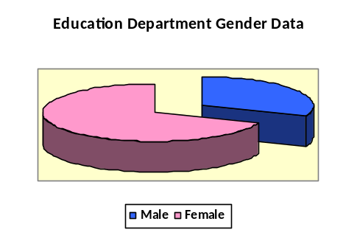
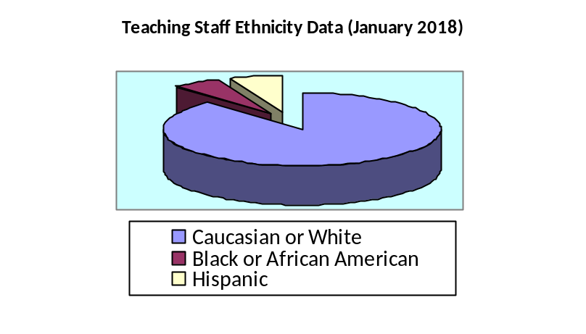
Support Staff
Oak Grove Center currently (January 2018) employs 381 staff members who provide a wide range of support for our students. Total employee ethnicity and gender data for all Oak Grove Center employees is as listed below:
Staff Gender Data (January 2018):
Male 27%; Female 73%
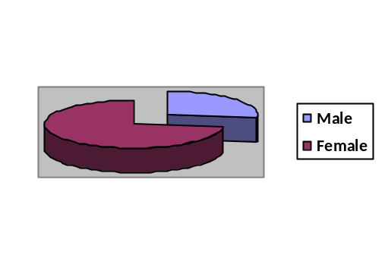

Staff Ethnicity Data (January 2018):
Caucasian or White 39.9%; Hispanic or Latino 28.9%; Black or African American 17.3%; Two or more races 8.9%; Asian 3.4%; Native Hawaiian or Other Pacific Islander 1.3%; American Indian or Alaska 0.3%
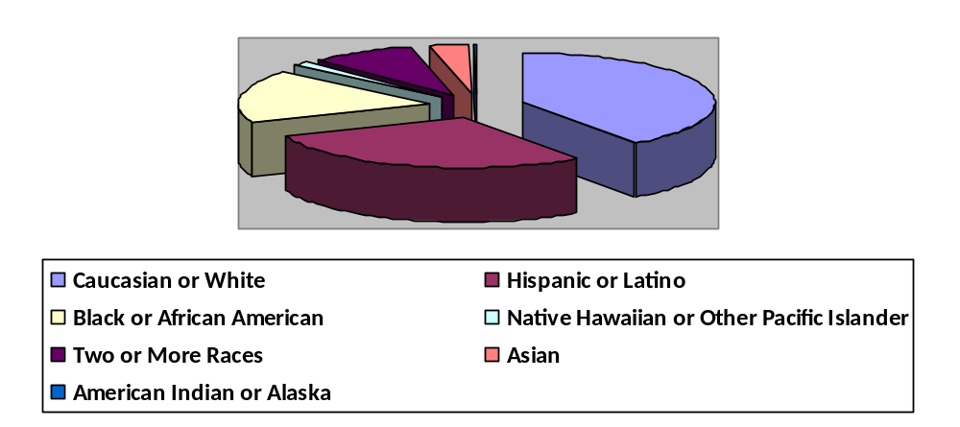

Therapists - Oak Grove Center employs licensed / credentialed therapists or therapist interns to serve the students enrolled in the school. Students enrolled in the school program receive a minimum of 60 minutes of individual therapy per week. Students may also receive group and / or family therapy if specified by the IEP team.
Nurses – Oak Grove Center has a nursing department. Oak Grove Center employs 5 full time nurses and a Director of Nursing.
DIS Service Providers – Oak Grove Center contracts with a Speech and Language Pathologist and Occupational Therapist. Oak Grove Center employs a Speech and Language Pathologist Assistant and a Certified Occupational Therapy Assistant to provide direct services to our students as specified in the student’s IEP.
Educational Assistants – Oak Grove Center employs educational assistants. Each classroom has a minimum of one Educational Assistant. Some classrooms have multiple Assistants depending on the population.
Curriculum and Instructional Materials
Listed below is the most current curriculum utilized for each grade level.
K-8
Gr. Lvl | Sub. | Curriculum | ISBN | Copyright | Publisher | State Approved
K | ELA | Benchmark Advance CA Edition | Y32593 / CA1986 | 2015 | Benchmark Education Company | Yes
K | ELA | Open Court Reading - Supplement | ISBN # 978007602729 | 2005 | SRA / McGraw Hill | No
K | ELA | Zoophonics - Kindergarten Kit | ISBN # 1886441243 | 2007 | Zoophonics | No
K | ELA | Complete Language Arts Skills Level 1 | ISBN # 9780076027286 | 2007 | McGraw Hill | No
K | ELA | Comprehension and Language Skills Levels 2,6 | ISBN # 0075707 | 2007 | McGraw Hill | No
K | ELA | Phonics Skills Level 1 | ISBN # 0075701987 | 2007 | McGraw Hill | No
K | ELA | Spelling and Vocabulary Skills Levels 1, 2, 6 | ISBN # 0075710978 | 2007 | McGraw Hill | No
K | ELA | Writer's Workshop Levels 2, 6 | ISBN # 0075695464 | 2007 | McGraw Hill | No
K | MAT | Go Math | ISBN # 978-0544203792 | 2015 | Houghton Mifflin Harcourt | Yes
K | MAT | Math Expressions - Supplement | ISBN # 139780547057095 | 2009 | Houghton Mifflin | No
K | SS | History / Social Science CA - Learn to Work | ISBN # 0328200492 | 2009 | Pearson / Scott Foresman | Yes
K | SS | Social Studies - Supplement |  |  | Franklin Schaffer | No
K | SCI | California Science | ISBN # 0022844260 | 2008 | Macmillian | Yes
K | SCI | Science Supplement |  |  | Franklin Schaffer | No
1 | ELA | Benchmark Advance CA Edition | Y30840 / CA1987 | 2015 | Benchmark Education Company | Yes
1 | ELA | Open Court Reading - Supplement | ISBN # 9780076027286 | 2005 | SRA / McGraw Hill | No
1 | ELA | Right into Reading - Supplement |  |  | Educators Publishing | No
1 | ELA | Reading - Phonics Rule - Supplement |  |  | Remedia Publishing | No
1 | MAT | Go Math | ISBN # 0544203836 | 2015 | Houghton Mifflin Harcourt | Yes
1 | MAT | Math Expressions - Supplement | ISBN # 139780547057170 | 2009 | Houghton Mifflin | No
1 | MAT | Spectum Math Skills - Supplement |  |  | McGraw Hill | No
1 | SS | History / Social Science CA - Time and Place | ISBN # 0328200506 | 2009 | Pearson / Scott Foresman | Yes
1 | SS | Reflections: CA Series, A Child's View Gr. 1 | ISBN# 0153384980 | 2007 | Houghton Mifflin Harcourt | Yes
1 | SCI | California Science | ISBN # 0022843752 | 2008 | Macmillian | Yes
2 | ELA | Benchmark Advance CA Edition | Y32594/CA1998 | 2015 | Benchmark Education Company | Yes
2 | ELA | Reading CA Edition 2 - Supplement | ISBN # 0618157166 | 2003 | Houghton Mifflin | No
2 | ELA | Moving into English |  | 2000 | Harcourt | No
2 | MAT | Go Math | ISBN # 0544203917 | 2015 | Houghton Mifflin Harcourt | Yes
2 | MAT | Math 54 Second Edition - Supplement | ISBN # 1565770331 | 2001 | Saxon | No
2 | MAT | Spectrum Math Skills - Supplement |  |  | McGraw Hill | No
2 | SCI | Science 2 CA Edition | ISBN # 0153176512 | 2002 | Harcourt | Yes
2 | SS | Reflections: CA Series, People We Know Gr. 2 | ISBN # 0153384999 | 2007 | Harcourt School Publishers | Yes
3 | ELA | Benchmark Advance CA Edition | Y30842/CA2433 | 2015 | Benchmark Education Company | Yes
3 | ELA | Reading CA Edition 3 - Supplement | ISBN # 061815782 | 2003 | Houghton Mifflin | No
3 | MAT | Go Math | ISBN # 0544203976 | 2015 | Houghton Mifflin Harcourt | Yes
3 | MAT | Math 54 Second Edition - Supplement | ISBN # 1565770331 | 2001 | Saxon | No
3 | SCI | Science 3 CA Edition | ISBN # 0153176520 | 2002 | Harcourt | Yes
3 | SS | Reflections: CA Series, Our Communities Gr. 3 | ISBN # 0153385014 | 2007 | Harcourt School Publishers | Yes
4 | ELA | Benchmark Advance CA Edition | Y30843/CA2434 | 2015 | Benchmark Education Company | Yes
4 | ELA | Reading CA Edition 4 - Supplement | ISBN # 0618157204 | 2003 | Houghton Mifflin | No
4 | MAT | Go Math | ISBN # 0544204050 | 2015 | Houghton Mifflin Harcourt | Yes
4 | MAT | Math 65 Second Edition - Supplement | ISBN # 1565770366 | 2001 | Saxon | No
4 | SCI | Science 4 CA Edition | ISBN # 0153176547 | 2002 | Harcourt | Yes
4 | SS | Reflections: CA Series, A Changing State Gr. 4 | ISBN # 0153385022 | 2007 | Harcourt School Publishers | Yes
5 | ELA | Benchmark Advance CA Edition | Y30844/CA2435 | 2015 | Benchmark Education Company | Yes
5 | ELA | Reading CA Edition 5 - Supplement | ISBN # 0618157212 | 2003 | Houghton Mifflin | No
5 | MAT | Go Math | ISBN # 0544204085 | 2015 | Houghton Mifflin Harcourt | Yes
5 | MAT | Math 76 Second Edition - Supplement | ISBN # 1565771532 | 2002 | Saxon | No
5 | SCI | Science 5 CA Edition | ISBN # 0153176555 | 2002 | Harcourt | Yes
5 | SS | Reflections: CA Series, US Making A New Nation Gr. 5 | ISBN # 0153385030 | 2007 | Harcourt School Publishers | Yes
6 | ELA | Benchmark Advance CA Edition | Y30845/CA2436 | 2015 | Benchmark Education Company | Yes
6 | ELA | Prentice Hall Literature (Copper Edition) - Supplement | ISBN # 0130547867 | 2002 | Prentice Hall | No
6 | MAT | Go Math | ISBN # 0544204115 | 2015 | Houghton Mifflin Harcourt | Yes
6 | MAT | Pre-Algebra CA Edition - Supplement | ISBN # 0130504866 | 2001 | Prentice Hall | No
6 | MAT | Middle School Math Course 2 - Supplement | ISBN # 0618050485 | 2001 | McDougall Littell | No
6 | SCI | Earth Science CA Edition | ISBN # 0030556678 | 2001 | Holt | Yes
6 | SS | Holt California Social Studies | ISBN# 0030734592 | 2006 | Holt, Reinhard & Winston | Yes
7 | ELA | Benchmark Advance CA Edition | Y30845/CA2436 | 2015 | Benchmark Education Company | Yes
7 | ELA | Prentice Hall Literature (Bronze Edition) - Supplement | ISBN # 0130547875 | 2002 | Prentice Hall | No
7 | MAT | Go Math | ISBN# 0544206984 | 2015 | Houghton Mifflin Harcourt | Yes
7 | MAT | Pre-Algebra CA Edition - Supplement | ISBN # 0130504866 | 2008 | Prentice Hall | No
7 | MAT | Algebra 1 CA Edition - Supplement | ISBN # 0130442631 | 2008 | Prentice Hall | No
7 | MAT | Middle School Math Course 2 - Supplement | ISBN # 0618050485 | 2001 | McDougall Littell | Yes
7 | SCI | Life Science CA Edition | ISBN # 0030556392 | 2001 | Holt | Yes
7 | SS | Holt California Social Studies | ISBN# 0030733995 | 2006 | Holt, Reinhard & Winston | Yes
8 | ELA | Benchmark Advance CA Edition | Y30845/CA2436 | 2015 | Benchmark Education Company | Yes
8 | ELA | Prentice Hall Literature (Silver Edition) - Supplement | ISBN # 0130547883 | 2002 | Prentice Hall | No
8 | MAT | Go Math | ISBN# 0544202610 | 2015 | Houghton Mifflin Harcourt | Yes
8 | MAT | Middle School Math Course 2 - Supplement | ISBN # 0618050485 | 2001 | McDougall Littell | Yes
8 | MAT | Pre-Algebra CA Edition - Supplement | ISBN # 0130504866 | 2008 | Prentice Hall | Yes
8 | MAT | Algebra 1 CA Edition - Supplement | ISBN # 0130442631 | 2008 | Prentice Hall | Yes
8 | SCI | Physical Science CA Edition | ISBN # 0030557976 | 2001 | Holt | Yes
8 | SS | Holt California Social Studies | ISBN# 0030412285 | 2006 | Holt, Reinhard & Winston | Yes
K-8 | ALL | Instructional Best Practices - A Curriculum Guide for Students with M/S Disabilities | Item # KT2559 / KT2242 | 2005, 2009 | SEACO
K-8 | ELA | Lexia Reading / Core 5 | Online Reading Program |  | Lexia Learning / Rosetta Stone
K-8 | MAT | IXL Math | Online Math Program |  | IXL Learning
K-8 | ALL | Acellus Online Learning Program - Common Core | Online Curriculum Program |  | Acellus

9-12
Gr. Lvl | Sub | Curriculum | ISBN # | Copyright | Publisher | District of Alignment
9 | ELA | Literature CA Edition Course 4 | ISBN # 007828144X | 2002 | Glencoe | Murrieta Valley USD
9 | ELA | Grammar and Composition Handbook | ISBN # 0078251192 | 2002 | Glencoe | Murrieta Valley USD
9 | MAT | Beginning Algebra with Applications | ISBN # 0618306056 | 2004 | McDougall Littell | Murrieta Valley USD
9 | MAT | Algebra - Supplement | ISBN # 0785414576 | 1998 | AGS Publishing | Murrieta Valley USD
9 | MAT | Algebra 1 CA Edition | ISBN# 0132031213 | 2008 | Prentice Hall | Murrieta Valley USD
9 | MAT | Algebra 1 - Common Core | ISBN # 9780133281149 | 2015 | Pearson | Temecula Valley USD / PUHSD
9 | SS | World Geography Today | ISBN # 0030509688 | 2007 | Holt | Murrieta Valley USD
9 | SS | World Geography - Supplement | ISBN # 0785424369 | 1998 | AGS Publishing | Murrieta Valley USD
9 | SCI | Lifetime Health | ISBN # 0030646146 | 2004 | Holt | Murrieta Valley USD
9 | SCI | Life Skills Health - Supplement | ISBN # 0785418598 | 1998 | AGS Publishing | Murrieta Valley USD
9 | SCI | Prentice Hall, Earth and Space Science | ISBN# 0131663089 | 2004 | Prentice Hall | Murrieta Valley USD
10 | ELA | Literature CA Edition Course 5 | ISBN # 0078281458 | 2002 | Glencoe | Murrieta Valley USD
10 | ELA | Grammar and Composition Handbook | ISBN # 0078251192 | 2002 | Glencoe | Murrieta Valley USD
10 | MAT | Geometry Concept and Skills | ISBN # 0618087583 | 2003 | McDougall Littell | Murrieta Valley USD
10 | MAT | Geometry - Common Core | ISBN # 9780133185829 | 2011 | Pearson | Temecula Valley USD / PUHSD
10 | MAT | Geometry - Supplement | ISBN # 0785422218 | 1998 | AGS Publishing | Murrieta Valley USD
10 | SS | Modern World History Patterns of Interactions CA Ed. | ISBN # 0618557156 | 2006 | McDougall Littell | Murrieta Valley USD
10 | SS | World History - Supplement | ISBN # 0785422129 | 1998 | AGS Publishing | Murrieta Valley USD
10 | SCI | Biology, The Living Science | ISBN # 0134155637 | 1998 | Prentice Hall | Murrieta Valley USD
10 | SCI | Biology - Supplement |  | 1998 | AGS Publishing | Murrieta Valley USD
11 | ELA | American Literature CA Edition | ISBN # 0078281466 | 2002 | Glencoe | Murrieta Valley USD
11 | ELA | Grammar and Composition Handbook | ISBN # 0078251192 | 2002 | Glencoe | Murrieta Valley USD
11 | ELA | American Literature -Supplement | ISBN # 0785418792 | 1998 | AGS Publishing | Murrieta Valley USD
11 | MAT | Foundations of Algebra 2 | ISBN # 0618595414 | 2007 | McDougall Littell | Murrieta Valley USD
11 | MAT | Algebra 2 CA Edition | ISBN# 0132031248 | 2008 | Prentice Hall | Murrieta Valley USD
11 | MAT | Algebra II - Common Core | ISBN # 9780133281163 | 2015 | Pearson | Temecula Valley USD / PUHSD
11 | MAT | Algebra 2 - Supplement |  | 1998 | AGS Publishing | Murrieta Valley USD
11 | SS | America's Journey CA Edition | ISBN # 0131955471 | 2006 | Prentice Hall | Murrieta Valley USD
11 | SS | US History - Supplement | ISBN # 0785425268 | 1998 | AGS Publishing | Murrieta Valley USD
11 | SCI | Conceptual Physical Science | ISBN # 0321516958 | 1999 | Addison Wesley | Murrieta Valley USD
11 | SCI | Physical Science - Supplement | ISBN # 0785422714 | 1998 | AGS Publishing | Murrieta Valley USD
12 | ELA | British Literature CA Edition | ISBN # 0078281474 | 2002 | Glencoe | Murrieta Valley USD
12 | ELA | Grammar and Composition Handbook | ISBN # 0078251192 | 2002 | Glencoe | Murrieta Valley USD
12 | MAT | PreCalculus 4th Edition | ISBN # 0669417416 | 1997 | DC Health & Co. | Murrieta Valley USD
12 | SS | Magruers American Government | ISBN # 013166803 | 2005 | Prentice Hall | Murrieta Valley USD
12 | SS | United States Government - Supplement | ISBN # 0785425039 | 1998 | AGS Publishing | Murrieta Valley USD
12 | SS | Economics Principles in Action | ISBN # 013181544 | 2005 | Prentice Hall | Murrieta Valley USD
12 | SS | Economics - Supplement | ISBN # 0785437703 | 1998 | AGS Publishing | Murrieta Valley USD
12 | SCI | Environmental Science | ISBN # 0030781361 | 2008 | Holt | Val Verde USD
K-12 | ALL | Instructional Best Practices - A Curriculum Guide for Students with M/S Disabilities (SEACO) | Item # KT2559 / KT2242 | 2005, 2008 | SEACO | Murrieta Valley USD
K-12 | ELA | Lexia Reading / Core 5 | Online Reading Program |  | Lexia Learning / Rosetta Stone | Temecula Valley USD
K-12 | MAT | IXL Math | Online Math Program |  | IXL Learning | Temecula Valley USD
K-12 | ALL | Acellus Online Learning Program - Common Core | Online Curriculum, All Subject Areas |  | Acellus | Coachella Valley USD

Student Achievement Data
Jack Weaver School and Oak Grove Center at the Ranch measure student progress in multiple ways. The primary goal of the program is to ensure that students are demonstrating consistent progress (educational and therapeutic) which enables them to successfully complete the program and transition to a lesser level of care. There are three main indicators for success within the program; academic achievement, attendance, and therapeutic & behavioral improvement that is sustained over time and across settings.

In terms of academic achievement, JWS and OGR utilize multiple means of measurement including standardized test scores, passing grades / credit attainment, and student portfolios / work samples. Data from our Lexia Reading Program is also utilized to determine if students are demonstrating growth in specific areas of reading. JWS and OGR will continue to utilize the standardized testing data to determine how the population is achieving on specific academic areas. Types of testing data utilized will change during the 15/16 school year due to changes in formal tests (CAHSEE is no longer being provided, STAR testing has changed to CAASPP, and WJIII has transitioned to WJIV). JWS and OGR make consistent effort to gather test data on students as both programs are still reliant on the individual student districts to receive this information.

Standardized Achievement Data (JWS & OGR Combined)

Woodcock Johnson III Tests of Academic Achievement (WJ III)
Due to the transient nature of the program, having two or more tests for students enrolled in the program is rare. However, when two or more tests occur it is important to utilize the data to determine if growth is being noted in specific areas. The WJ III is a good measure for individual student progress. Data below contains information obtained from both JWS and OGR.

For the WJ III Tests of Academic Achievement, eight areas of the test were measured; Total Achievement (S1), Broad Reading (S2), Broad Math (S3), Broad Written Language (S4), Academic Skills (S5), Academic Fluency (S6), Academic Applications (S7) and Academic Knowledge (S8).

Data for 2013 – 2015 demonstrate that more students showed an increase in performance for sections 1 (Total Achievement), 2 (Broad Reading), 3 (Broad Math), 4 (Broad Written Language), 7 (Academic Applications) and 8 (Academic Knowledge). An equal number of students showed an increase and decrease in performance for sections 5 (Academic Skills) and 6 (Academic Fluency). A few students did not show a difference in scores for specific areas over the two tests.

Overall, growth was noted in multiple areas for the majority of students when two test comparisons were made.
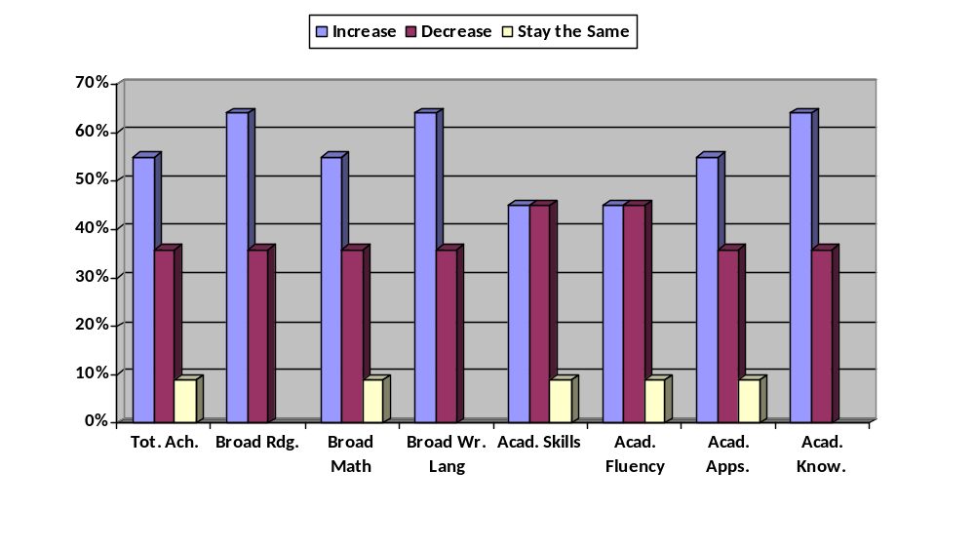
(n = 21)

Standardized Testing Accountability Reporting (CAPA / CST / CMA)
Between 2013-2015 JWS and OGR collected data for the CAPA, CST, or CMA. Test participation level is determined by student IEP based on student need. Over this timeframe, 23 students had 2 tests used for comparison data. For these tests ELA and Math tests were studied. Student performance on the test was characterized by the following categories; Far Below Basic (FBB), Below Basic (BB), Basic (B), Proficient (P) and Advanced (A). Results of the testing and data analysis indicate the following:

Test 1 | English / Language Arts | Mathematics
Far Below Basic | 4% | 26%
Below Basic | 26% | 22%
Basic | 35% | 17%
Proficient | 13% | 22%
Advanced | 22% | 13%

Test 2 | English / Language Arts | Mathematics
Far Below Basic | 11% | 16%
Below Basic | 11% | 21%
Basic | 16% | 16%
Proficient | 37% | 21%
Advanced | 26% | 26%

Data indicate that more students performed in the Basic, Proficient or Advanced levels for both tests. For Test 1, 70% of students were Basic or above for ELA and 52% were Basic or above for Mathematics. For Test 2, 79% of students were Basic or above for ELA and 63% were Basic or above for Mathematics. Students also showed improvement across tests with more students performing in the Basic or above levels for both ELA (70%-79%) and Math (52%-63%) on Test 2.
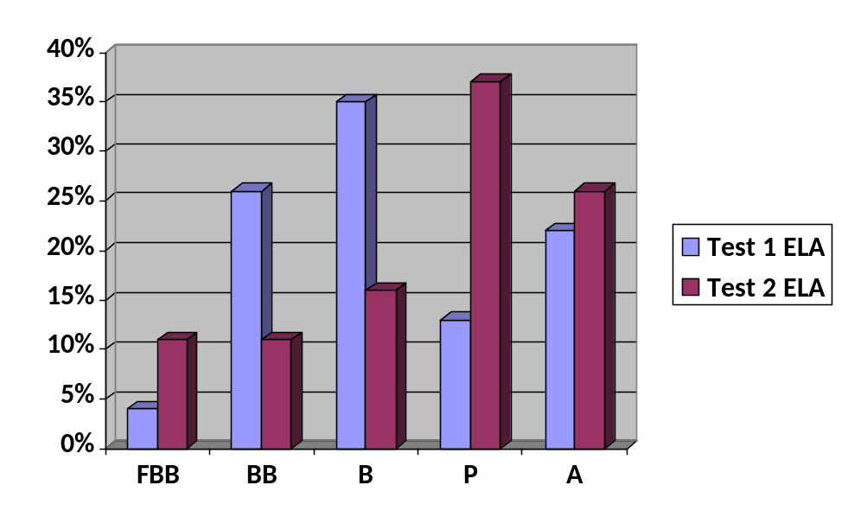
(n=23 T1 / n=19 T2)

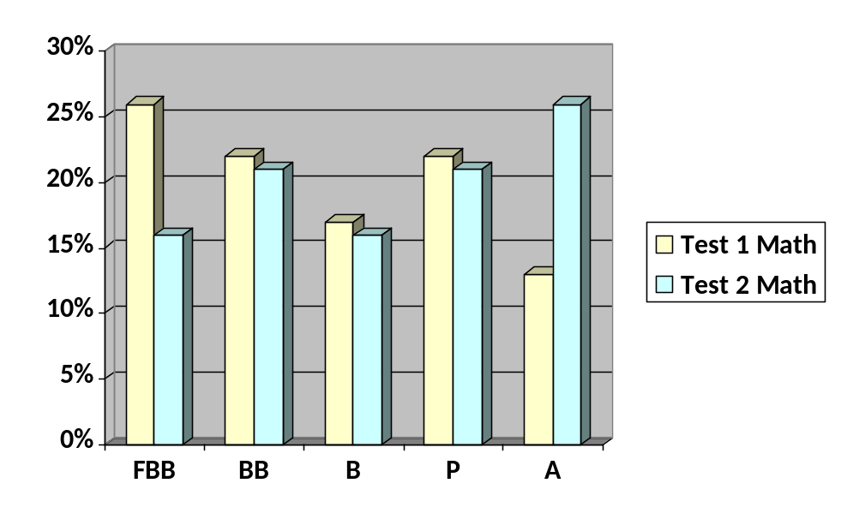
(n=23 T1 / n=19 T2)

Student Follow-Up Data
The number of students who graduate (earn diploma or certificate of completion) or transition from elementary to middle school or middle to high school is driven by the makeup of the student body during each particular school year. High school students earn diplomas / certificates of completion once all State / district requirements are met and / or they age out of the program. Typically students in elementary / middle school promote when age / grade level determines it is appropriate. Very rarely, an elementary / middle school student does not promote at the expected timeframe; this is an IEP team decision.

For the past three years, program transition data indicate the following:

- 2014/15: High School Graduates, 7; Certificate of Completion, 1; transition from Kindergarten to 1st grade, 1; transition from elementary to middle school, 14; and transition from middle to high school, 12.
- 2015/16: High School Graduates, 8; Certificate of Completion, 2; transition from elementary to middle school, 3; and transition from middle to high school, 8.
- 2016/17: High School Graduates, 8; Certificate of Completion, 2; transition from elementary to middle school, 6; and transition from middle to high school, 15.

Students exit the program when the IEP team determines that the student has made significant progress and would benefit from a lesser restrictive setting (mainstreaming, transition back to public school, etc.), when the student completes his / her education by earning a high school diploma or certificate of completion, or if the student ages out of a specific program (18 for residential and 22 for JWS / OGR). A student may also exit the program if the IEP team determines that the services available are no longer meeting the student’s needs. Parents may choose to remove their students from the program as they deem appropriate, although they are strongly encouraged to work within the confines of the IEP team. Students can enter or exit the program at any point as recommended by the IEP team. When students exit the program, JWS and OGR determine what level of progress has been noted and assign a discharge label as follows:
- Completion / Graduate – student has successfully completed the program, demonstrates significant progress on treatment goals / IEP goals, ready for transition to a lower level of care.
- Planned – Other programs / options were recommended due to limited progress on treatment goals / IEP goals or student change of address / district.
- Premature – Student leaves the program against recommendation of the treatment team / IEP team.
- During the 16/17 school year, the Planned / Premature categories were combined into one – Did Not Complete Program. Typically all discharges are “Planned”, so it is more appropriate to have the one category.

Discharge data for JWS is as follows:
09/14 – 08/15 | Graduate | Completion | Planned | Premature
JWS | 28% | 20% | 32% | 20%

09/15 – 8/16 | Graduate | Completion | Planned | Premature
JWS | 27% | 34% | 19% | 20%

09/16 – 08/17 | Graduate | Completion | Did Not Complete Program
JWS | 30% | 28% | 42%

Data for JWS indicate that during 14/15 school year 48% of discharges were at the completion or graduate level, during the 15/16 school year 61% of the discharges were at the completion or graduate level, and during the 16/17 school year 58% of the discharges were at the completion or graduate level. Continued good progress with over 50% of the population demonstrating significant progress on treatment and IEP goals to discharge from the program appropriately to lesser levels of care.

Overall, continued good progress and a positive measure of growth / success for our students.

Credit Attainment for High School Students
JWS also tracks passing of classes (K-8) and credit attainment (9-12) as a measure of student progress. This data is important in determining educational progress and growth of the student body as a whole. All students enrolled in the program have experienced significant school difficulties that have impeded their ability to be successful in a general education environment. For high school students, this typically means entering the program with credit deficiencies or at risk of credit deficiencies. JWS focuses on helping students learn behaviors and gain necessary academic skills to achieve in a more typical classroom setting. Students are required to attend class, participate in lectures and projects, and complete assigned coursework and tests. Grades are based on positive performance in these areas. Data is monitored over reporting periods that align with progress reports and report cards. Data over the last 3 years is as follows:

 | Jan 15 | Apr 15 | Jun 15 | Aug 15 | Nov 15
JWS | 85% | 81% | 81% | 88% | 80%

 | Feb 16 | Apr 16 | Jun 16 | Aug 16 | Nov 16
JWS | 81% | 83% | 91% | 97% | 91%

 | Feb 17 | Apr 17 | Jun 17 | Aug 17 | Nov 17
JWS | 95% | 88% | 95% | 97% | 83%

Data indicate positive performance in this area with all reporting periods being 80% or above. This is significant since students are not placed in the program unless they are not achieving academically which is historically measured by lack of passing academic courses enrolled in. Typically students must show failure over an extended period of time and within different settings following district continuum of care guidelines (Gen Ed, RSP, SDC, SEAS, etc.) prior to being recommended for NPS level of care.

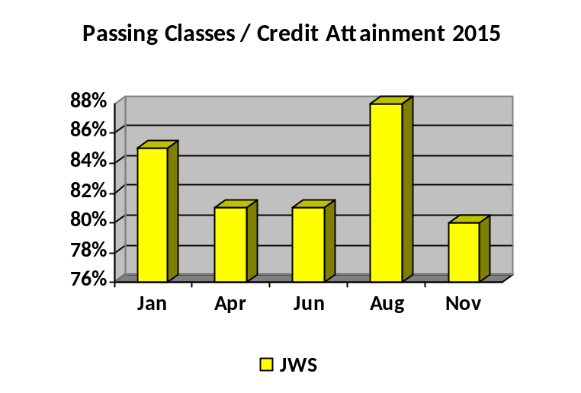

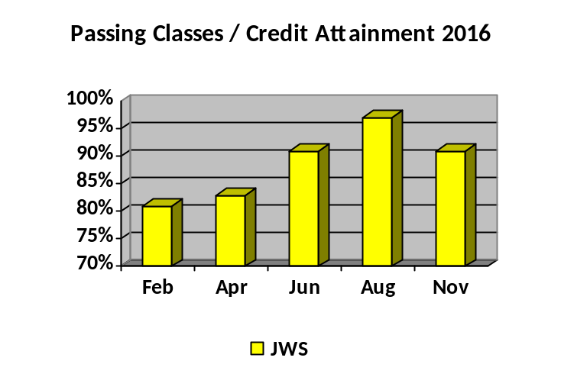

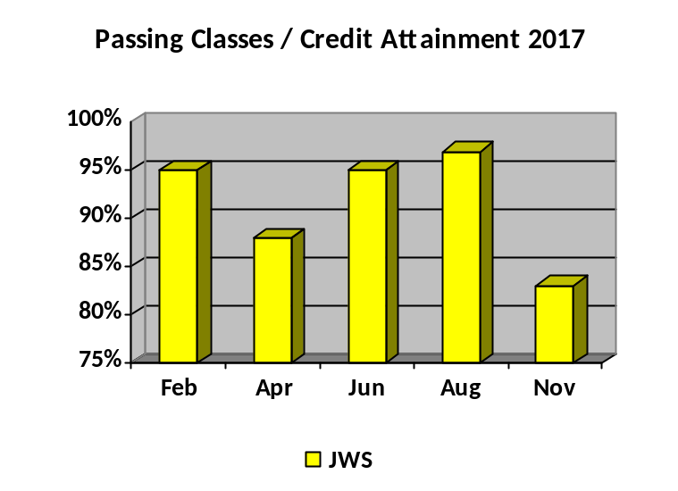

Positive Attendance
Students at JWS are required and encouraged to attend school daily and on time. Attendance is tracked daily for all students and attendance rates / patterns are monitored. If attendance difficulties are noted, specialized incentives are implemented to increase Average Daily Attendance (ADA) rates. Students earn behavior bucks, privileges, attendance awards, attendance incentive money (day students), and specialized outings when positive attendance is noted. Many students are admitted to the program with severe attendance difficulties, so focus on positive attendance is of upmost importance for our students. Attendance data (ADA rate) over the past 3 years is as follows:

 | Jan 15 | Apr 15 | Jun 15 | Aug 15 | Nov 15
JWS | 92% | 91% | 90% | 91% | 91%

 | Jan 16 | Apr 16 | Jun 16 | Aug 16 | Nov 16
JWS | 90% | 91% | 90% | 89% | 93%

 | Jan 17 | Apr 17 | Jun 17 | Aug 17 | Nov 17
JWS | 91% | 89% | 86% | 91% | 89%

JWS tends to have a consistent attendance rate with 88% or higher attendance during reporting periods. This rate is slightly higher than would typically be expected due to having the residential program students who tend to attend more consistently since they live on campus. Students who attend solely for school require much more consistent involvement for positive attendance rates. Overall, 80% or higher attendance rates are necessary to help ensure the longevity of all programs and to help our students to gain skills necessary to transition back into a less structured setting. Those students who are not receptive to school attempts at increased attendance and who continue to exhibit negative attendance patterns are discussed with district personnel and change of placement is considered if all attempts have been exhausted.

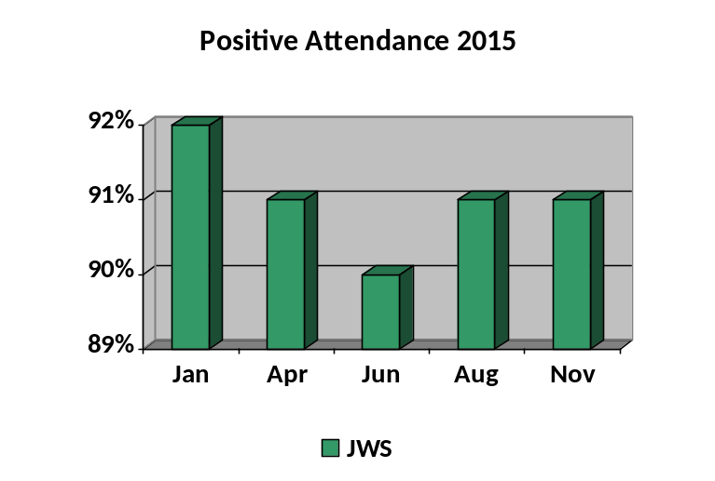
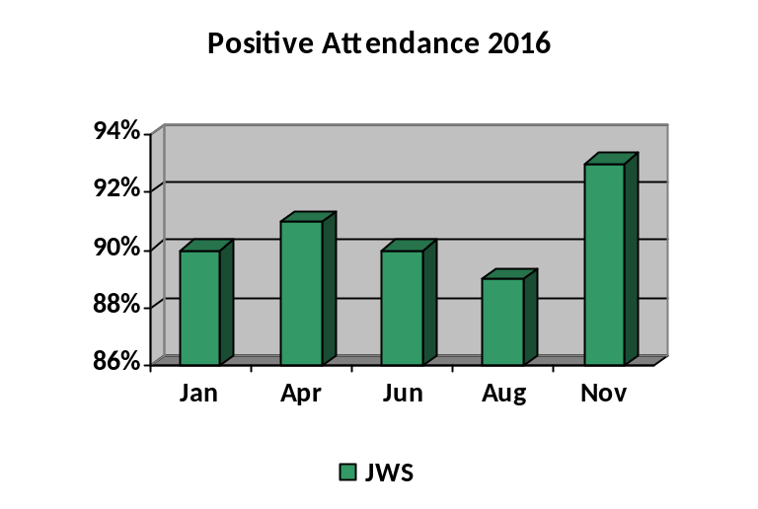
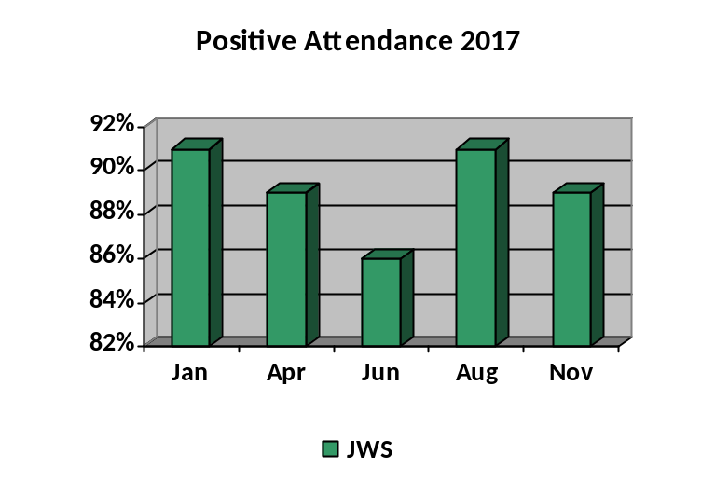

Professional Development

Professional development needs of the school and teachers are determined by school administration observation / survey data (school stakeholders including teachers, parents, students, district personnel, etc.) and are based on current needs of the school and staff as well as on-going or new trends in education. Professional development trainings focus on improving the overall structure of the school program to ensure on-going compliance and high standards. Topics may include IEP trainings related to compliance and changes in law, curriculum development / implementation related to state standards, instructional methods, testing and assessment (including trainings mandated by the state for CAHSEE, CSTs, CAPA, or CMAs), behavior intervention trainings, and classroom quality assurance trainings / reviews.

“All staff” professional development needs are determined by staff input, evaluation form feedback from prior trainings, staff suggestions, new trends (Livesafe, DBT, Autism Awareness, Why Try, etc.), and implementation trainings related to new programs and/or procedures. All staff professional development trainings infuse Oak Grove Center’s Mission and Values related to our facility wide culture of accountability.

Oak Grove Center also follows district contractual requirements as well as CDE requirements related to mandatory yearly all staff development. Such trainings include; Proactive Interventions, Fire Safety, CPR / First Aid, Federal False Claims Act Training, Child Abuse Reporting, Anti-Harassment Training and Cultural Diversity.

It is the policy of Oak Grove Center Center to ensure competency and quality of the Clinical Therapy staff, consisting of professionals providing case management and mental health therapy services. The peer review process is designed to ensure competence of Clinical practitioners through the review of case presentations, relevant training, or experience; current competence and the ability to perform clinical responsibilities. All Clinical staff members are required to participate in the peer review process, presenting to the entire team at a minimum of twice yearly. Professional Development needs of the Clinical staff are determined by the needs of the client population and trends in the literature and research related to Evidenced Based Practices. Oak Grove Center Center prides itself in ensuring that the Clinical Staff are equipped with the most up to date information, research, and practices designed to meet the ever changing needs of our students. We routinely and regularly provide either all staff in-house training or send Clinical Staff to educational seminars designed to be utilized with our students and enable them to share the information in all-staff in-services. Some of the latest trainings have included DBT, Attachment Theory, Seeking Safety, and Fetal Alcohol Syndrome.

Teachers are granted two (2), pre-authorized, Professional Days as part of their employment contract for the purpose of furthering their education. Should the Teacher attend a conference, or enroll in a testing program to maintain or obtain credentialing during one or both of these Professional Days, Oak Grove Center pays up to two hundred-fifty ($250) dollars for tuition. Teachers are responsible for all other expenses related to these conferences and/or testing enrollment.

Oak Grove Center also ensures that teachers remain appropriately credentialed to work with the population of students that they serve. During the 12/13 school year, Oak Grove Center paid for any teachers requiring Autism Authorization to gain this certification.

Oak Grove Center encourages on-going professional development and works closely with the districts we serve to provide access to district wide trainings to ensure on-going professional development and program quality.

Commitment
Oak Grove Center / JWS is committed to the students, families and outside organizations that we serve. Our goal is to provide the best, most appropriate education for our unique population of students. We do not take lightly our responsibility to serve our students, families, districts and other agencies in the best way possible and appreciate all of the support that we are provided.


Empowering Success * Transforming Lives

