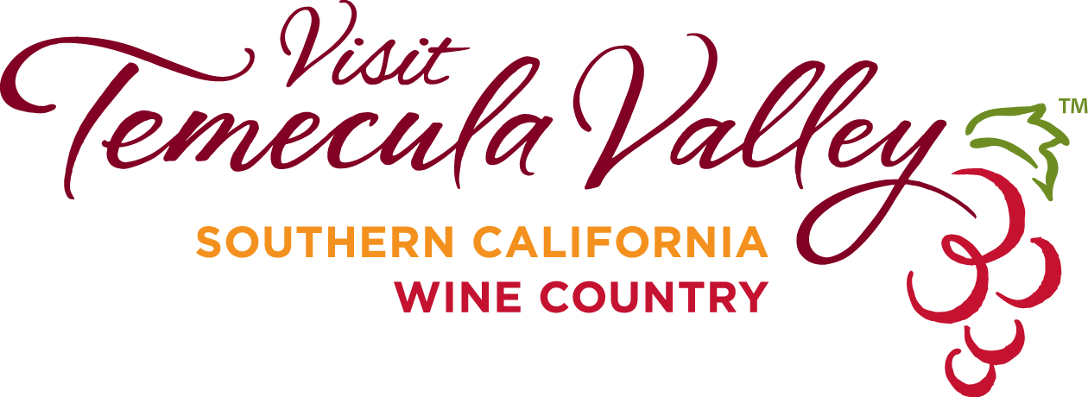

FOR IMMEDIATE RELEASE

MEDIA CONTACT
Annette Brown
Director of PR
Visit Temecula Valley
Annette@VisitTemeculaValley.com
951-252-2141

Visit Temecula Valley Announces Xenia Hospitality Award Winners

TEMECULA, CALIFORNIA, July 21, 2020 – This year, due to the coronavirus pandemic, Visit Temecula Valley Xenia Awards was a live Zoom event. Awards were presented on a pre-recorded video; however, the recipients were surprised when the Visit Temecula Valley hospitality committee showed up to announce the news. Awards were given in seven categories: Social Media, Culinary, Ambassador, Hospitality, Brewery of the Year, Winery of the Year, and Tourism Professional of the Year. In addition, 23 employees at various businesses in Temecula Valley received recognition through Spotlight on Service for their outstanding customer service.

Social Media Award
For the greatest impact promoting and attracting visitors to Temecula Valley Southern California Wine Country through social media, the Social Media Award winner is Peltzer Farm & Winery. Their posts are well presented with brand personality, making great use of Instagram stories and custom stickers. Peltzer grew to 24,100 Instagram followers since opening in 2015. They have a consistent strong engagement at the customer level. In addition, they strategically post events on their channels with excellent use of calendar skills.

Champion Culinary Award
This award recognizes a locally owned restaurant or chef operating in Temecula Valley demonstrating an exceptional dining experience through its service excellence, innovation, culinary offerings, and community philanthropic activities. The Champion Culinary Award recipient is Oak Grove Culinary Creations. They have created an opportunity for youth at Oak Grove Center (a nonprofit residential, educational, and treatment center for children through California with psychological, emotional and behavioral problems, and special needs) to explore and excel in the culinary field. Through their program, career paths in the culinary arts have been introduced and new pathways have opened for youth.

Ambassador Award
The Ambassador Award recognizes an individual that generates significant economic impact for the region by encouraging tourism and securing major conventions and events. The winner of the Ambassador Award is Diane Strand, founder at JDS Creative Academy and president/producer at JDS Video & Media Productions. Strand has created significant events generating positive exposure for Temecula Valley with both national and international recognition. The company is a sustainable job creator and a significant contributor to philanthropic causes in the valley.

Hospitality Award
This award recognizes a tourism organization or business that demonstrates outstanding hospitality to visitors and exhibits a team spirit in promoting travel tourism and the growth of Temecula Valley. This year there was a tie in the voting process; the two winners are Avensole Winery and Old Town Temecula Community Theater. Both recipients exhibit exemplary hospitality through their elevated service.

Golden Tap Brewery of the Year
This is a new recognition for the emerging brewery industry in Temecula Valley. This category is for brewers, breweries, distillers, and distilleries that produce quality beers and spirits, build a strong local partnership, and provide service excellence and valuable industry education to visitors. The inaugural winner is 8 Bit Brewing Company. This company demonstrates job creation in an emerging industry, possesses service and community focus in their company philosophy, and produces award-winning beers.

Cilurzo Award for Winery of the Year
This award recognizes a winery operating in Temecula Valley that routinely offers exceptional guest experience through its wine, vineyard quality and appearance, philanthropic endeavors, and betterment of the community. The winner is South Coast Winery. They have a strong family philosophy of quality service and have been producing outstanding wines for decades. South Coast Winery promotes the Temecula Valley Wine Country brand through numerous events, they offer an exceptional wine country experience, and they have extended the Temecula Valley Southern California Wine Country brand through features in various national and international magazines and television. The winery has a strong commitment to quality wines, vineyards, winemaking, and philanthropic endeavors.

Welty Award for Tourism Professional of the Year
This title goes to a tourism professional who has made significant contributions to our hospitality industry through their strong commitment to Temecula Valley, as well as their innovation, inspiration, and industry leadership. The winner is Mike Rennie with Temecula Valley Winery Management. He has worked tirelessly to elevate the customer experience through exceptional product offerings, extraordinary guest service, and outstanding representation of Temecula Valley. His commitment to growth in the valley has shape the tourism landscape through his diversified company offerings.

Spotlight on Service Awards
Spotlight on Service shines special recognition on exceptional, authentic, warm, and front line Temecula Valley hospitality employees. Recipients are Randy Wikert at Grapeline Wine Tours, Leeana Geuy at Rene’s Cowgirl Cantina, Mark Kim at Sushi Boat, Liz Amoros at Lucille’s Smokehouse BBQ, Julian Carillo at Build-a-Bear Workshop, Jan Dowe at Brighton Collectibles, Philippe Dornic at The Vineyard Rose, Danyell Cortopassi at The Vineyard Rose, Adriana Aragon at South Coast Winery Resort & Spa, Alex Cervantes at Pechanga Resort Casino, Casey Price at The Gambling Cowboy, Lauren Strickland at The Gambling Cowboy, Terri Bobbe at Wilson Creek Winery, Markelle Brown at Wilson Creek Winery, Arlene Eyerman at Temecula Carriage Company, Nicole Berry at Temecula Carriage Company, Amber Williams at Red Robin Temecula, Kristy Campbell at Falkner Winery, Tina Tackett at Falkner Winery, Carol Post at Old Town Spice & Tea Merchants, Sean Suthers at E.A.T. Marketplace, Brooke Woodside at California Pizza Kitchen, and Gilmarie Villegas at Bluewater Grill.

In 2019, Visit Temecula Valley produced a tourism economic impact of $2,064,990. Projected visitors for 2019 are 3.3 million. The lodging revenue was $89 million, which is an 8.5 percent increase from the previous year. Marketing efforts produced 61.4 million paid impressions, 2.1 million website pageviews, a 15.2 percent increase in website unique viewers, 759,397 leisure hotel searches, $576,502 direct hotel revenue, 419 million media impressions, and $11.1 million value in free coverage.

This year, tourism in Temecula Valley began stronger than ever until the industry was hit with a worldwide pandemic. The destination has demonstrated strength, unity, and innovation during this unprecedented time. Together, the businesses in Temecula Valley are working side by side to make it through a very challenging time, creating safe experiences for local visitors.

About Visit Temecula Valley
Visit Temecula Valley (VTV), a nonprofit 501c(6) organization funded by the Temecula Valley Tourism Business Improvement District, Pechanga Development Corporation, the City of Temecula, the Temecula Valley Wine Country Tourism Marketing District, and tourism-related businesses, is the destination marketing organization in the Temecula Valley. VTV increases awareness of Temecula Valley, stimulates Temecula Valley economic growth and tourism, and measures visitor spending in the Temecula Valley. VTV is online at www.VisitTemeculaValley.com. For membership information or visitor assistance, please call (888) 363-2852 or (951) 491-6085.

###

